**HP 564/564XL Ink Cartridges – Facts, Compatibility and Price Comparison**

* Short description, story, why it is popular, etc… max 2 paragraphs
* What is the difference between HP 564 vs HP 564XL

|  |  |  |
| --- | --- | --- |
| **Cartridge Model** | **Ink Capacity** | **Page Yield** |
| 564 | 7.5mL | 250 pgs. |
| 564XL | 14mL | 550 pgs. |

* How many pages do you print per week? Frequency you need to order replacement

|  |  |  |
| --- | --- | --- |
| Printer pages per week | HP 564 replacement frequency | HP 564XL frequency |
| 5-10 pages | Every 6 months | *Every 1 year |
| 20-25 pages | Every 2-3 months | Every 6 months |
| 35-40 pages | Every 1-2 months | Every 3-4 months |
| ~50 pages | **Every month | Every 2-3 months |

*If you are replacing your ink once in a year, there is a high possibility that your ink will dry-up in your printer.

** We are recommending you to order high yield versions, or ordering bundles to save on ink

* Where to find these inks, and what are the prices

|  |  |  |  |
| --- | --- | --- | --- |
| HP Store | Walmart | Staples | Compatible Ink |
| $191.91  http://optus.intelliresponse.com/uploads/StoreLocator.png | $123.97  http://optus.intelliresponse.com/uploads/StoreLocator.png | $133.97  http://optus.intelliresponse.com/uploads/StoreLocator.png | $52.11  C:\Users\Marketing1\Desktop\button3.png |

* What is the difference between OEM vs Compatible inks
* Where is the closest office supply store (automatically show the map depending on the IP)

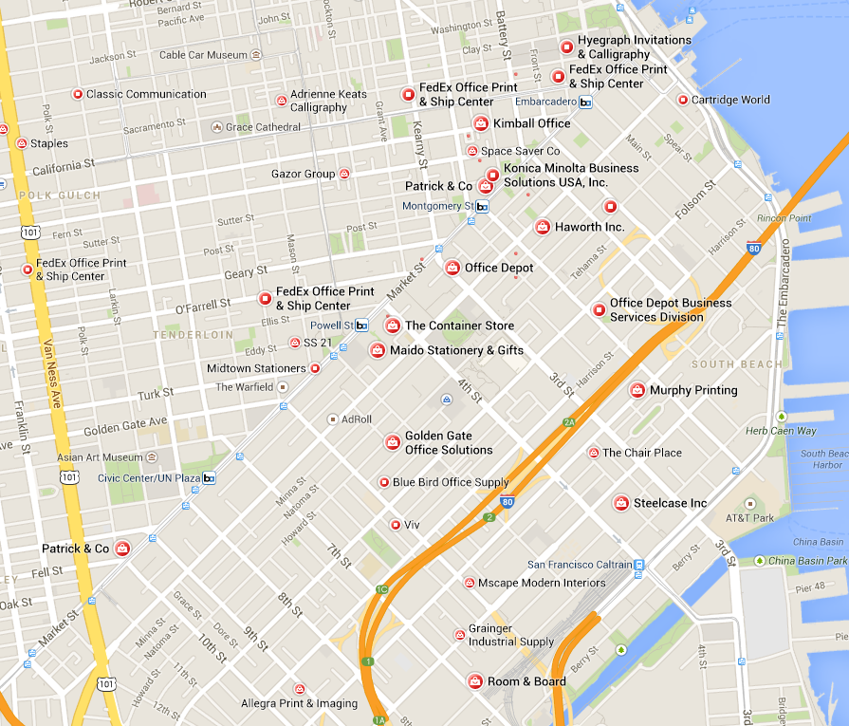

* Create a custom greeting card now
* Share your experience with others, or leave your comments

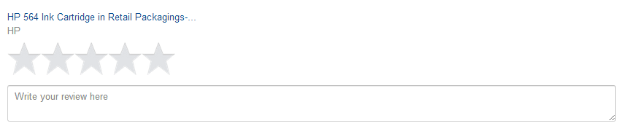

Name

E-mail Address (won’t be shared with others)

